**INTRODUCTION**

Covid-19, as this name is well-known to everyone in the world. Corona virus, also known as COVID-19, is an infectious disease that affects the respiratory system of people. The term "Covid 19" refers to a new corona virus illness that was identified in that year. Our daily lives have been impacted by the Corona Virus. Millions of individuals have been impacted by this pandemic, who have become sick or are dying because of the disease's spread. The Lockdown had implemented on the several countries by restricting people to their homes, allowing to go out for supplies in the specific intervals of time.  Many people try to adjust to working online, homeschooling their kids, and using Online ordering to get groceries, while others are forced to be exposed to the virus to maintain society. Considering the situation, studies and clinical trials were started, but it required enough time for a vaccine to be created and made available on the market. Before being made accessible to the public, vaccines often go through years of development and testing. Preclinical and clinical vaccines, which are tested on animals and people, respectively, were produced after several trials and experiments. By 2022, at least 80 vaccines will have undergone clinical testing on humans. Ultimately, the trials, attempts, and challenges led to the creation of a limited number of vaccines from various countries that are now used and supplied all over the world.

This Vaccination served as my inspiration to evaluate, examine on the vaccination trails of different countries. I have explored the several websites to accumulate the vaccine data around the world. I have made visualizations to achieve some facts and conclusions which helped me to understand the data. Your numbers may be turned into an interesting narrative with details and trends by using data visualization. We can spot new patterns thanks to data visualization, and we can act quickly based on what we observe.

Visualizing patterns make more sense when graphically portrayed because humans find it simpler to identify highly linked variables when given with images and diagrams. Humans comprehend visual images 60,000 times faster than they do written texts. When information is presented as a graph, chart, or other visual representation, the brain finds it easier to process.

I have visualized the Vaccine data like number of vaccines administered, literacy rates, GDP of the country, human development index, across different countries and regions. I have formulated the research questions for each visualization.

1. How many number of doses administered per 100 for each Country?
2. What are the top five countries in the vaccination administered?
3. What are the top 10 countries in the full and Partial Vaccination rate?
4. What is the bottom 10 countries in the Full and Partial Vaccination?
5. Does the literacy rate of each country have any correlation with the Vaccination rate?
6. Does the GDP of each country have any correlation with the Vaccination rate?
7. What is the Vaccination rate of each continent and region?
8. Does the Human Development index have any correlation with the Vaccination rate?

**METHODOLOGY:**

I have modeled the visualizations using the Six Datasets for the final project and all of them are found in Kaggle, Data. World, Wikipedia. The datasets are Worldwide Vaccine Data, Different Countries Excel, GDP Per Capita, Literacy Rates of the country, 2020-2021 Covid data, Human development Index. The Description of the datasets are given below:

* Worldwide Vaccine Data has fields of Name of the Country, Total Doses Administered in the country, total doses administered per 100 people, percentage of with at least one dose, percentage of population that is fully Vaccinated.
* Countries Excel Dataset has the Name of the Country, Regions of the Country, Continent of the Country.
* Literacy Rates has the fields of Countries, ISO Code of the Country, Literacy Rate of the Country
* GDP Dataset has the fields of the Country, Total GDP of that Country, GDP Growth of that Country, and GDP Per capita of the Country.
* New Covid Data has the fields of the Country Name, Age of 65 and 70 years older, Human Development Index, Rank of the Country in terms of HDI.

**REFERENCES:**

* <https://www.kaggle.com/datasets/anandhuh/latest-worldwide-vaccine-data>
* <https://ourworldindata.org/grapher/gdp-per-capita-worldbank>
* <https://ourworldindata.org/literacy>

**ANALYSIS**

**Question 1:**

How many number of doses administered per 100 for each Country?

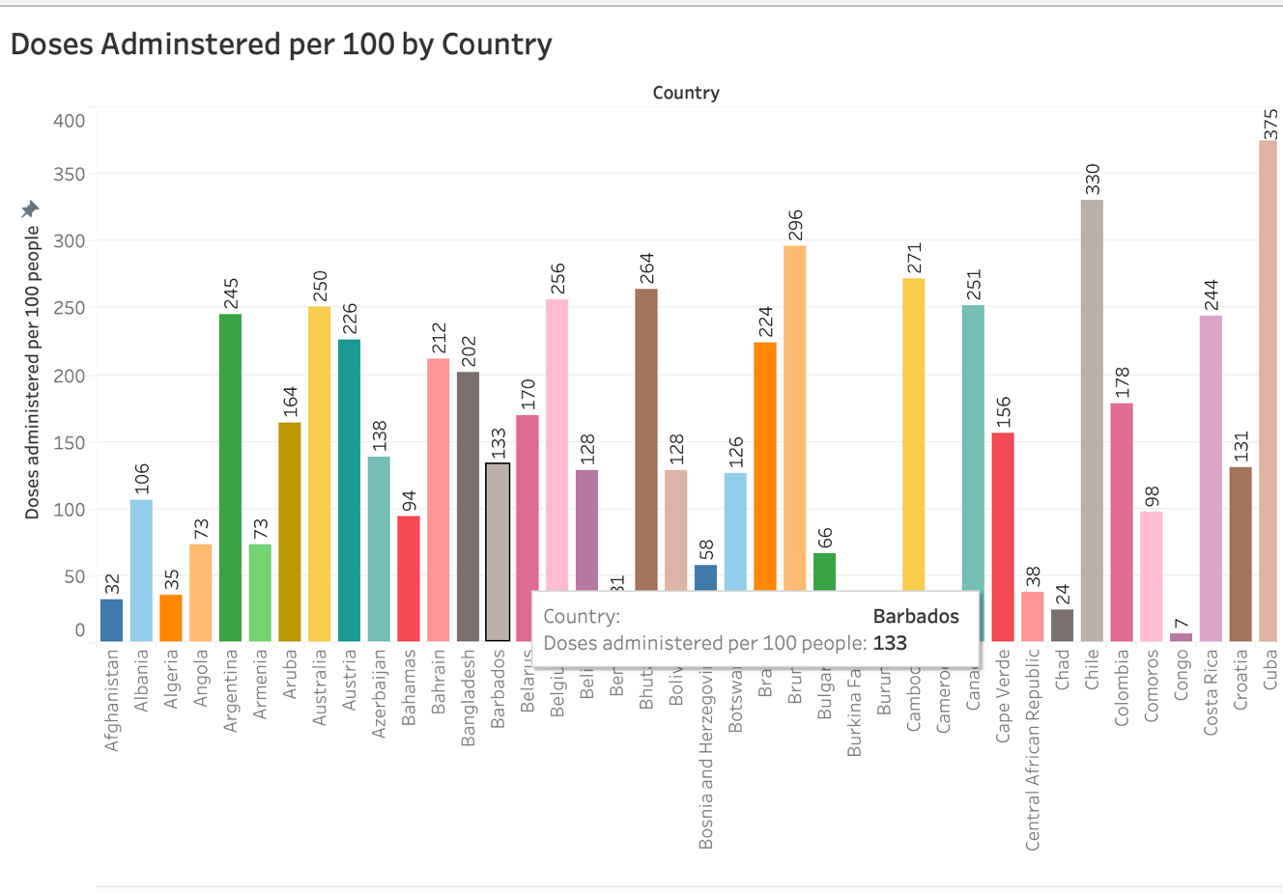

**FIGURE:1**

**DESCRIPTION:**

I have visualized the data of country in fields and doses administered per 100 in rows. From the above visualization Cuba has administered the highest number of doses per 100 followed by the Chile and Brunei. The lowest doses are recorded in Yemen followed by Haiti. The population in these areas are very low. I have used the filter of color for the country to distinguish the different between countries.

**QUESTION 2:**

What are the top five countries in the vaccination administered?

**FIGURE2:**

**DESCRIPTION:**

I have Visualized the data of Country in fields and Total doses administered in rows. From the above visualization Mainland China has administered the highest total doses in the world of 3.4 billion followed by the India of 2.19 billion and followed by United states of 0.6 billion. There are total of 13.02 billion doses administered globally and 2.4 million are administered each day. The China and India are the most populous countries in the world, because of that they have highest number of vaccines. However, India has done very well competing with other populated countries in terms of vaccines administered.

**QUESTION 3:**

What are the top 10 countries in the full and Partial Vaccination rate?

**FIGURE:3**

**DESCRIPTION:**

I have visualized the bar chart of country in fields and percentage of fully vaccinated, percentage of partial vaccinated. It shows the Qatar, Brunei, UAE has the highest percentage of vaccination rate of 99% followed by Macau, Malta and Chile compared to other countries because of less population, more wealth and more vaccination procedures followed in these countries. The other countries having high population like China, India, Russia, USA has less vaccination rate the less rate is because of manufacturing and Mass production of vaccines and distributing around the world. The countries are differentiated by colors and sorted by vaccination rate. For instance, the developed country like USA has less vaccination rate and less population compared to India, and other countries. There are some obstacles that prevents the vaccination process like access to vaccination. Despite the vaccine supply, there are still vaccine deserts where access is limited. In its COVID vaccine launch, the US placed less emphasis on primary care settings, ignoring the locations where most individuals receive other vaccinations and the medical workers who may counsel them on the advantages and disadvantages of each. Stronger primary care relations allowed other countries to count on them.

**QUESTION 4:**

What is the bottom 10 countries in the Full and Partial Vaccination?

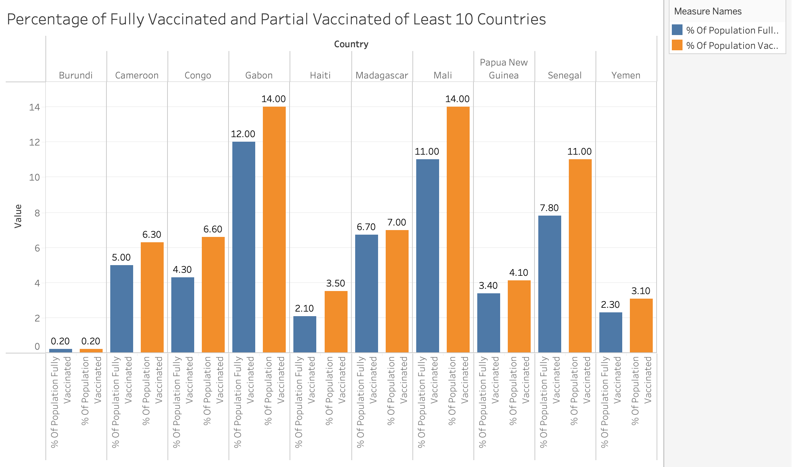

**FIGURE:4**

**DESCRIPTION:**

I have visualized the bar chart of country in fields and percentage of fully vaccinated and percentage of partial vaccination and filtered to show the least 10 countries in performing less vaccination rate. Burundi has less full vaccination rate of 0.2% and followed by Haiti of 2.1%, Yemen of 2.3%. The main reason for low vaccination is due to poor transportation difficult to transport the samples to reference laboratories. Half of the Yemen’s healthcare facilities are destroyed by the war and many doctors have died or fled the country, putting a high stress on the clinics and hospitals that are still working. Limited access to the health care, political difficulties are the primary causes of low vaccination in Burundi, Yemen, and Haiti. Low-income nations had to wait months to get their doses of the vaccinations when they were distributed across the world in 2020, either through the COVAX vaccine-sharing scheme or through other donors, as wealthier nations had purchased most of the vaccines available. Some of Yemen's wealthier neighbors, such Qatar, and the United Arab Emirates, have immunized more than 95% of their populations since the vaccine's launch.

**QUESTION 5:**

Does the literacy rate of each country have any correlation with the Vaccination rate?

**FIGURE:5**

**DESCRIPTION:**

I have visualized the scatter plot of literacy rate of country with the percentage of full vaccination rate. From the above visualization it shows that countries having high literacy rates and healthcare facilities have higher vaccination rates. Pakistan, Bangladesh Egypt, Algeria have low literacy rate, so the vaccination rate is also low for that countries. Due to the complicated knowledge and several processes required for successful vaccine adoption, low or limited literacy is linked to a decreased adoption of preventive behaviors like immunization. Despite, the countries like USA, Hungary, Finland have higher literacy rate, the vaccination rate is low because the other factors like healthcare, political influence, resistance to the vaccine in the society plays a major role in the full vaccination. The low literacy rate also affects the communication, knowledge about the immunization and how to overcome the disease, unable to use the internet and social media. I need to consider the other factors to get accurate results.

**QUESTION 6:**

Does the GDP of each country have any correlation with the Vaccination rate?

**FIGURE:6**

**DESCRIPTION:**

I have created a scatter plot of GDP of a country and the percentage of fully vaccination. From the above visualization it shows that countries having low GDP Per capita has less vaccination rate and Countries having higher GDP has more Vaccination rate. However, some countries have more vaccination regardless of the Gross domestic product of that country. Economic measures like GDP, Human development index has played a vital role in the vaccine distribution as they have direct relationship between the social measures, health infrastructure. There are other factors like socio economic status directly associated with covid-19 vaccination rate. Public health infrastructure, strategy for vaccine distribution nationwide are two factors play major role in the vaccination rate.

**QUESTION 7:**

What is the Vaccination rate of each continent and region?

**FIGURE:7**

**DESCRIPTION:**

I have created a bar chart to display the average vaccination rate with the continents and regions. I have created a drill down measure to continent and region. From the above visualization it shows that all continents except the Africa have 60%-75% full vaccination. The Africa has only 27.77% of vaccination rate because of vaccine shortages and resistance of the vaccine due to health issues. Rich Countries were able to get ahead and save twice covid-19 vaccines like COVAX. But the poorer countries like most in Africa had to wait for the covid Vaccine distribution. According to WHO, Africa has produced less than 1 percent of vaccine and importing 99% vaccines all time. The poor health infrastructure and lack of government organizations in Africa has affected the Vaccination rate.

**QUESTION 8:**

Does the Human Development index have any correlation with the Vaccination rate?

**FIGURE:8**

**DESCRIPTION:**

I have modeled the scatter chart of country, Human Development index, and percentage of population of fully Vaccinated as shown in the above figure. From the visualization it shows that Countries having low Human Development index has low Vaccination rate and countries having higher Human development index has more vaccination rate. High development index countries have stable governments, good healthcare facilities, affordable education, and high life expectancies. The countries like Niger, Burundi, Central African Republic has Index around 0.4 which are comes under the less developed countries. The countries like Switzerland, Norway, Iceland etc. have high Human development index.

**DASHBOARD: 1**

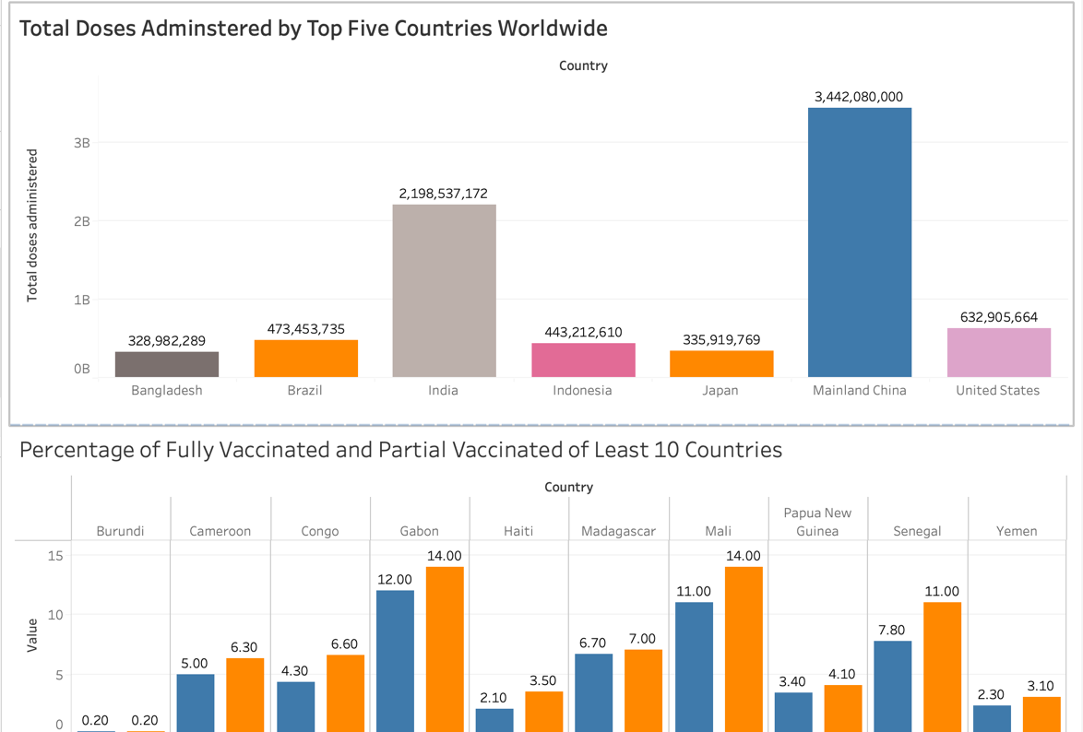

**DASHBOARD 2:**

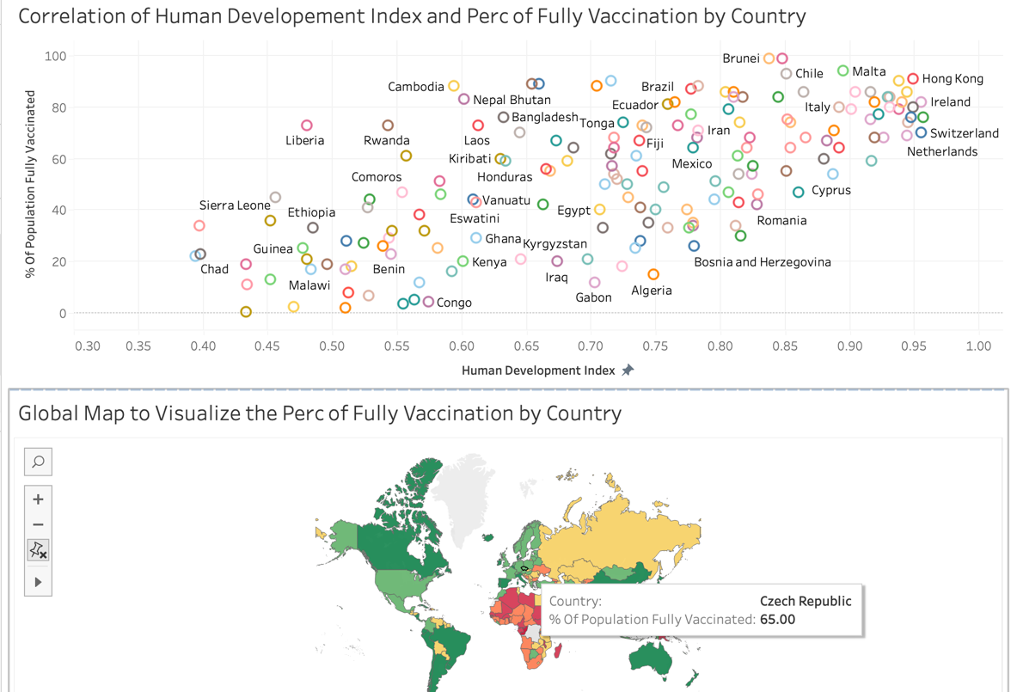

**CONCLUSIONS**

* From Figure 1, Cuba has highest doses administered per 100 people followed by Chile and Brunei.
* From Figure 2, China has administered highest number of total doses of 2.9 billion followed by India and United states of America. China “Zero Covid” strategy was implemented to reduce the covid cases count to zero. Sinovac and Sinopharm are two Chinese vaccine manufacturers produced the vaccine massively to accommodate Chinese mass population.
* From Figure 3, Qatar, U.A.E, Brunei, has highest vaccination rate compared to the populous country like China, India, Russia, USA. Qatar implemented the national immunization program which extensively vaccinated all age groups in the country.
* From Figure 4, Burundi, Yemen, Haiti have less full and Partial Vaccination rate because of poor healthcare facilities, poor infrastructure, and less transport facilities. There are other factors that affected the less developed countries like Yemen, Haiti are malnutrition, and other morbidities which increased the death toll even after the vaccination.
* From Figure 5, Countries having higher literacy rate have higher vaccination rate. Some countries like USA, Hungary also have higher literacy rates, but the vaccination rate is mostly depending on the healthcare facilities, production of vaccines, Acceptance of Vaccine by the people and political factors.
* From Figure 6, Higher GDP has High Vaccination rate and low GDP countries have less Vaccination rate. However, there are some countries have higher vaccination rate but low literacy rate. GDP measures the 63% variation in the vaccination rate.
* From Figure 7, all continents like North America, Europe, Asia, Oceania except Africa has high average full vaccination rate. Africa has less vaccination rate of 27% because of Vaccine shortages and poor Medical Facilities. Africa only produced 1% vaccines inside and remaining 99% vaccines are imported. The countries richer than Africa has bought the supplies delaying the vaccines supply to Africa. Moreover, Africa has suffered five covid waves.
* From Figure 8, Countries having the high Human development index has high vaccine rate and less human development index has less vaccination rate.

**ADDITIONAL RESEARCH QUESTIONS:**

1. What is the death rate after taking Vaccine?
2. What type of Vaccines are most used in different countries?
3. Comparison of different age groups in terms of Vaccine intake?
4. Is there any other side effects increased after taking Covid Vaccine?
5. Which country has manufactured more supplies and distributed to other countries?